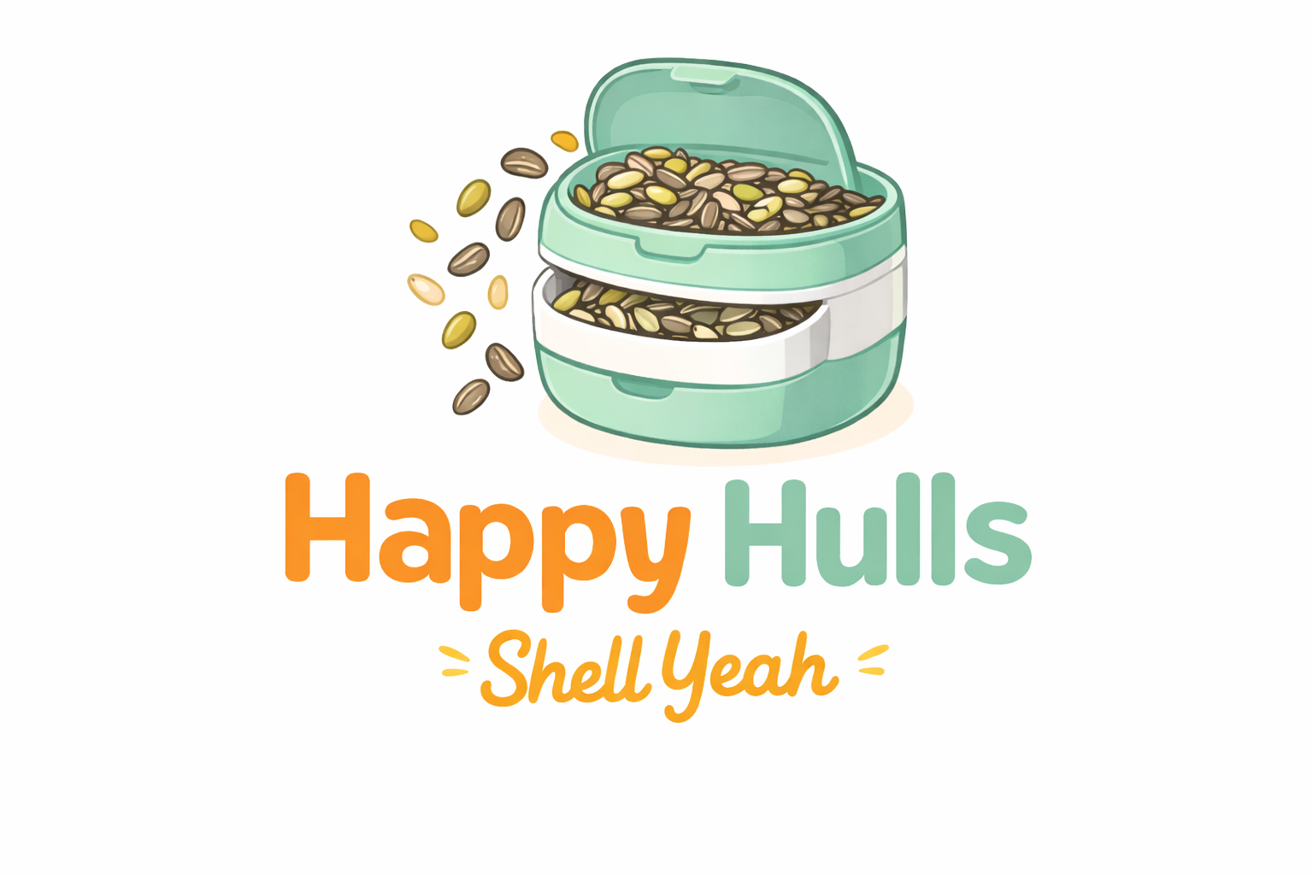
Instruction Manual for Shell Yeah:
A Dual-Compartment Seed Container
Danielle Spann
ENGL220 Technical Writing
Professor Rosalie Yezbick
American Military University
March 1, 2026

Table of Contents

Tools Needed for Assembly ...................................... 3
Product Overview ............................................... 3
Introduction .................................................. 3
How to Use Shell Yeah ........................................... 4
Assembly Instructions ........................................... 4
Safety Warnings ................................................ 4
Contact Information ............................................. 5
Troubleshooting and FAQs ........................................ 5
Cleaning and Care ............................................... 5
Instruction-Writing Process ..................................... 6

Instruction Manual for Shell Yeah
Introduction
Thank you for choosing Happy Hulls’ Shell Yeah. We created this product because we understand the small frustrations that come with enjoying sunflower or pumpkin seeds, especially the mess that follows. Whether you are at a game, on a road trip, studying, or relaxing at home, Shell Yeah was designed to keep your snacking experience clean, convenient, and stress-free. Our unique dual-compartment system separates fresh seeds from discarded shells in one compact container, eliminating the need for cups, bags, or improvised solutions. By combining portability, sanitation, and simplicity, Shell Yeah offers a cleaner and more organized way to snack, so you can focus on enjoying the moment.
Product Overview
Shell Yeah includes a secure top lid, an upper compartment for fresh seeds, a middle divider, and a lower compartment for discarded shells. The divider prevents mixing and maintains sanitation. The compact design prioritizes cleanliness and portability.
Tools Needed for Assembly
No tools are required. Shell Yeah arrives fully assembled. If disassembled for cleaning, it can be reassembled by hand without additional equipment.
Safety Warnings
Not recommended for children under three years old. Do not microwave unless specified. Avoid direct flame or high heat. Ensure lid is securely closed before transport. Do not overfill compartments. Discontinue use if damaged. Always wash before first use and after each use.
Assembly Instructions
If reassembling after cleaning: Insert divider securely into base groove. Attach upper compartment and secure in place. Close lid until locked. Gently shake to test stability.
How to Use Your Happy Hulls (Shell Yeah!)
First—Fill.
Start by opening the top compartment and filling it with your favorite seeds. Be sure not to overfill so the lid can close securely.
Next—Chill.
Close the lid and take your Happy Hulls with you wherever you go. Kick back, relax, and enjoy your snack—no mess, no stress.
Then—Snack smart.
As you eat, place your empty shells into the bottom compartment to keep everything clean and organized.
Finally—Toss.
When you’re done, open the bottom section and dispose of the shells. Rinse if needed, and you’re all set for next time.
Cleaning and Care
Wash with warm water and mild soap before first use. Hand washing is recommended. If dishwasher safe, place on top rack only. Ensure all parts are dry before reassembling.
Troubleshooting and FAQs
If lid does not close, check for overfilling or debris. If shells mix with seeds, ensure divider is installed correctly. If odor develops, soak in warm water with baking soda and air dry.
Contact Information
Email: support@happyhulls.com | Phone: (888) 123-HULL | Website: www.happyhulls.com. Include purchase date, issue description, and photos if applicable. Responses are typically within 1–2 business days.

Instruction-Writing Process
Target Audience
The target audience includes individuals aged 15–45 who frequently consume sunflower or pumpkin seeds, including athletes, students, outdoor enthusiasts, and office workers. Many value convenience and cleanliness.
Design Decisions
Design focused on clarity and readability. Bold headings improve navigation. White space prevents clutter. Step-by-step formatting improves usability. Alignment, contrast, repetition, and proximity guided layout.
Problems Encountered
A challenge was anticipating misuse such as overfilling or improper cleaning. Research on food container safety informed warnings. Balancing professionalism with brand personality was also considered.
Planning Steps
Planning began by identifying the product’s unique selling point: clean seed disposal in one container. Standard manual sections were outlined before drafting, and graphics were planned to support comprehension.

